ONEWAY Memory BY HAD
/STATISTICS DESCRIPTIVES HOMOGENEITY WELCH
/PLOT MEANS
/MISSING ANALYSIS.

Oneway

Notes
Output Created |  | 05-May-2019 23:34:03
Comments
Input | Active Dataset | DataSet0
Input | Filter | <none>
Input | Weight | <none>
Input | Split File | <none>
Input | N of Rows in Working Data File | 30
Missing Value Handling | Definition of Missing | User-defined missing values are treated as missing.
Missing Value Handling | Cases Used | Statistics for each analysis are based on cases with no missing data for any variable in the analysis.
Syntax |  | ONEWAY Memory BY HAD  /STATISTICS DESCRIPTIVES HOMOGENEITY WELCH  /PLOT MEANS  /MISSING ANALYSIS.
Resources | Processor Time | 00 00:00:00.140
Resources | Elapsed Time | 00 00:00:00.156

[DataSet0]

Descriptives
Memory
 | N | Mean | Std. Deviation | Std. Error
1-4 hours per day | 10 | 84.2700 | 18.23347 | 5.76593
4-8 hours per day | 6 | 72.9167 | 22.27312 | 9.09296
Less than an hour a day | 9 | 132.0556 | 32.44654 | 10.81551
More than 8 hours per day | 5 | 72.6780 | 3.80998 | 1.70387
Total | 30 | 94.4030 | 33.66618 | 6.14658

Descriptives
Memory
 | 95% Confidence Interval for Mean |  | Minimum | Maximum
 | Lower Bound | Upper Bound | Minimum | Maximum
1-4 hours per day | 71.2266 | 97.3134 | 60.75 | 126.00
4-8 hours per day | 49.5425 | 96.2909 | 48.00 | 106.25
Less than an hour a day | 107.1149 | 156.9962 | 64.50 | 166.00
More than 8 hours per day | 67.9473 | 77.4087 | 67.50 | 77.25
Total | 81.8318 | 106.9742 | 48.00 | 166.00

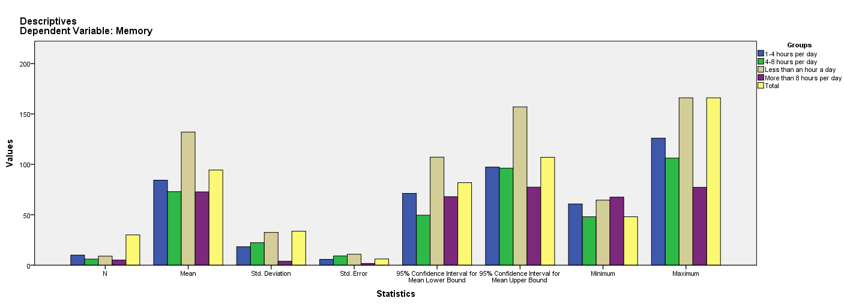

Test of Homogeneity of Variances
Memory
Levene Statistic | df1 | df2 | Sig.
2.415 | 3 | 26 | .089

ANOVA
Memory
 | Sum of Squares | df | Mean Square | F | Sig.
Between Groups | 18916.065 | 3 | 6305.355 | 11.749 | .000
Within Groups | 13952.880 | 26 | 536.649
Total | 32868.945 | 29

Robust Tests of Equality of Means
Memory
 | Statisticª | df1 | df2 | Sig.
Welch | 9.718 | 3 | 12.298 | .001
a. Asymptotically F distributed.

Means Plots

